Finding Wrecks
Activity Description: Underwater archaeologists use a variety of methods to find and identify sites. Some methods are very “high tech”, like side scan sonar and magnetometer remote sensing, while others are less so, like snorkel or SCUBA diver surveys. The Great Lakes are one place where the water is so clear that archaeologists can identify wrecks from aerial photography! This isn’t something that you can do many places and is a good way to get a sense of the area you are surveying before planning any more documentation or excavation. For this assignment, you will look at the aerial photographs of Lake Michigan and circle what you identify as potential wrecks. Look carefully, because there may be more than one potential wreck in the photograph.
Duration: 15 min
Learning Objectives:
- Learn how to identify shipwrecks using photography
- Understand what Lake Michigan shipwrecks look like in an archaeological context
- Apply this method to identify wrecks in several aerial photographs
Vocabulary:
Survey: A type of research archaeologists to search for archaeological sites, collecting data about the location, distribution, and organization of past people over a large geographical area.
Anomaly: An irregularity identified during remote sensing that could be an archaeological feature or site.
Side scan sonar: A survey method used by underwater archaeologists to create images of the seafloor. The sonar sensors send and receive acoustic pulses that map the seafloor and detect other anomalies.
Magnetometer: A method used by archaeologists to detect magnetic anomalies on the Earth’s surface, which may indicate archaeological sites.

Image #1
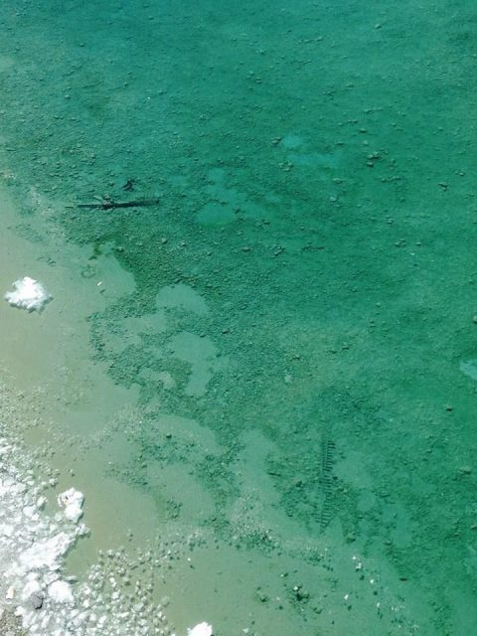

Image #2

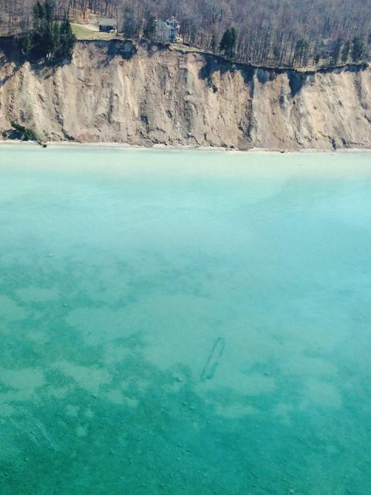

Image #3

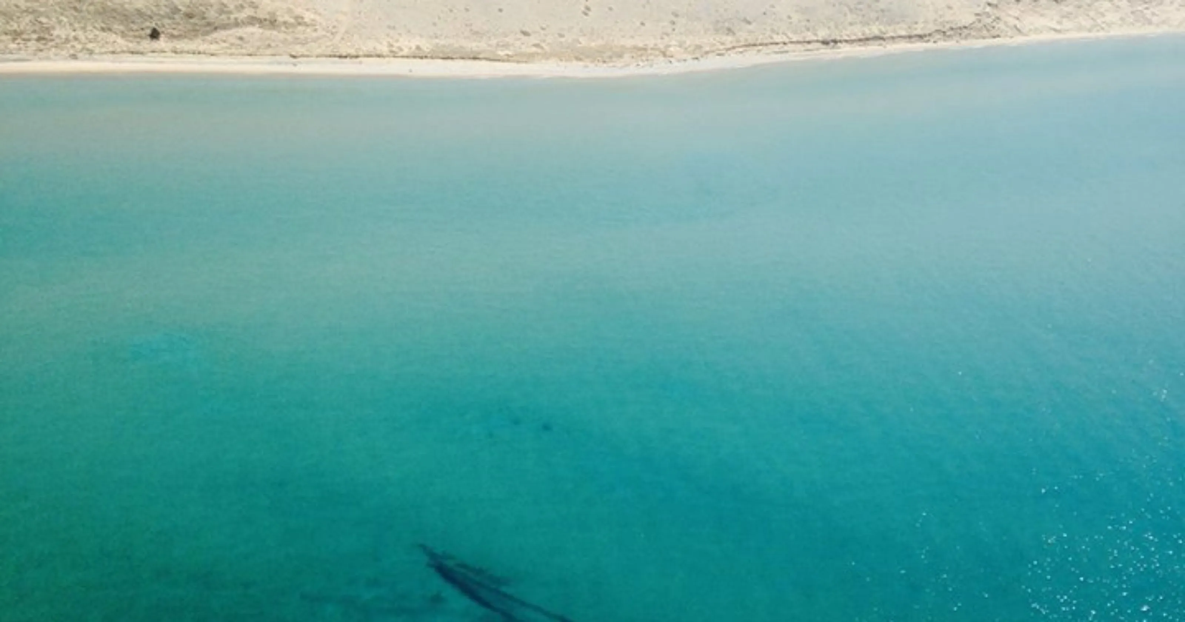

Image #4

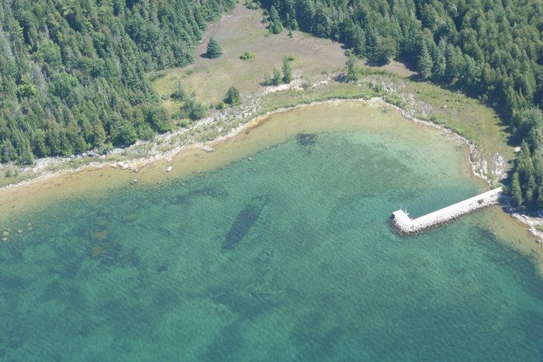

Image #5

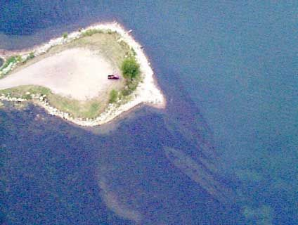

Image #6

